Kepler–Poinsot Polyhedra

Definition
# Source: AI Source: Provided by: [Data Path: Persons Table -> ID Column: 1, Name_En Column: Motasem Essam] -> From: [ChatGPT] on [7/25/2026]
Kepler–Poinsot Polyhedra are the four non-convex regular polyhedra in three-dimensional Euclidean geometry. They are also known as Regular Star Polyhedra.
They extend the concept of regular polyhedra beyond the five convex Platonic solids by allowing:
- Self-intersecting polygonal faces, such as pentagrams.
- Intersecting faces, where the planes of different faces pass through one another.
- Star-shaped vertex configurations, where the arrangement of faces around a vertex follows a regular star pattern.
All four polyhedra have highly symmetrical structures. Their faces are congruent regular polygons or star polygons, and their vertices have identical configurations.
The four solids are named after the mathematicians Johannes Kepler and Louis Poinsot, who investigated and described these geometric forms.

Geometric Representation
# Source: AI Source: Provided by: [Data Path: Persons Table -> ID Column: 1, Name_En Column: Motasem Essam] -> From: [ChatGPT] on [7/25/2026]
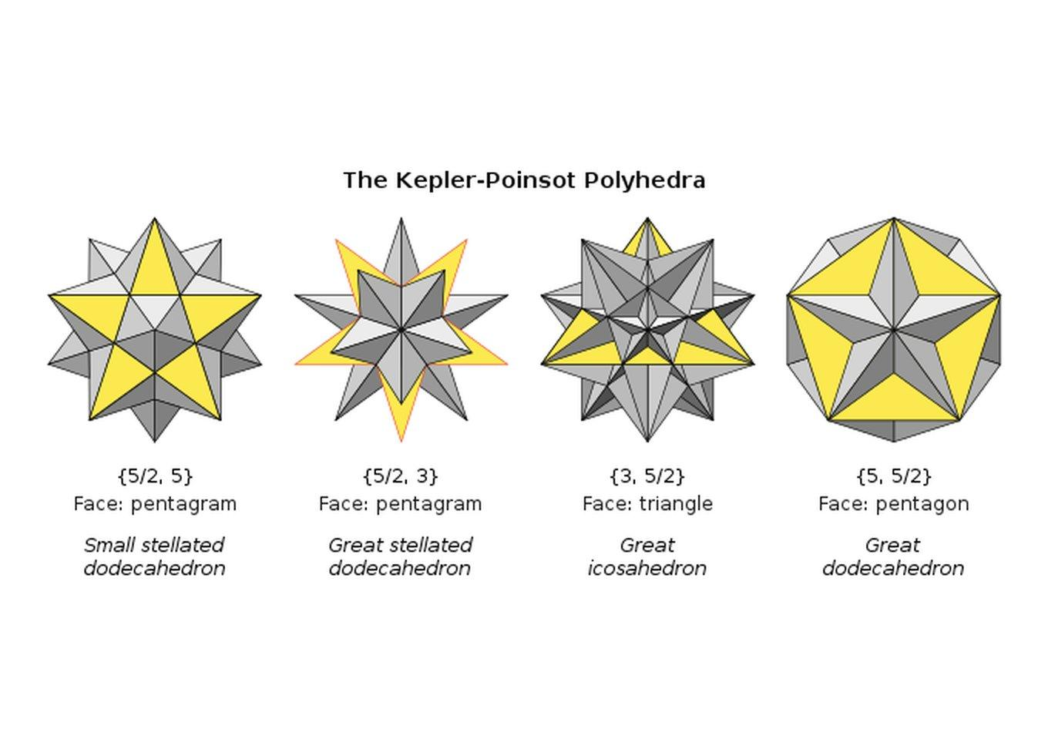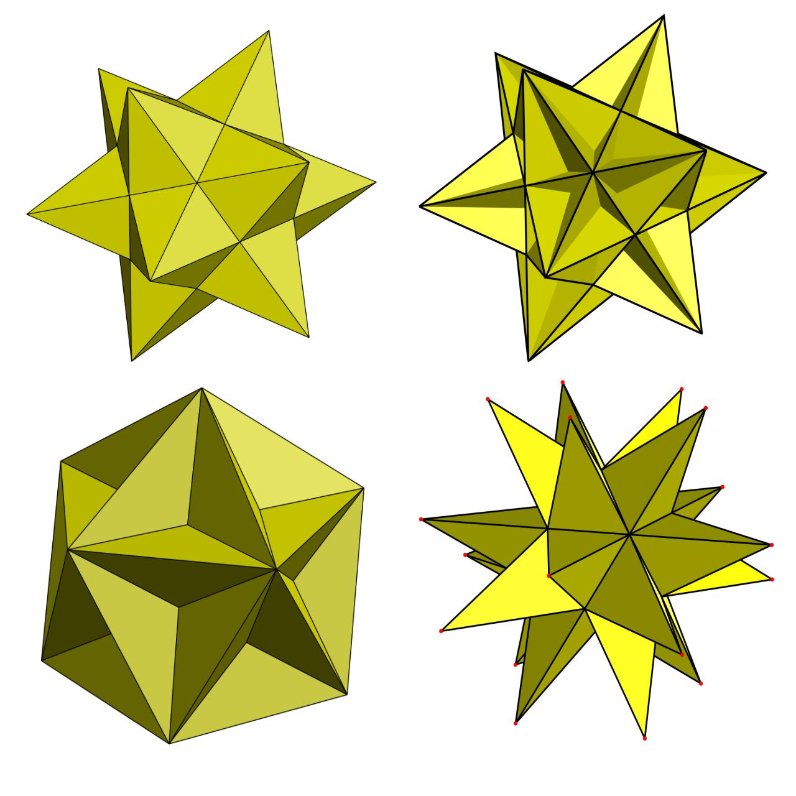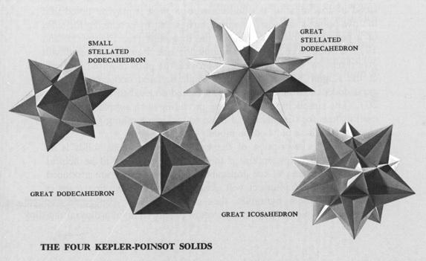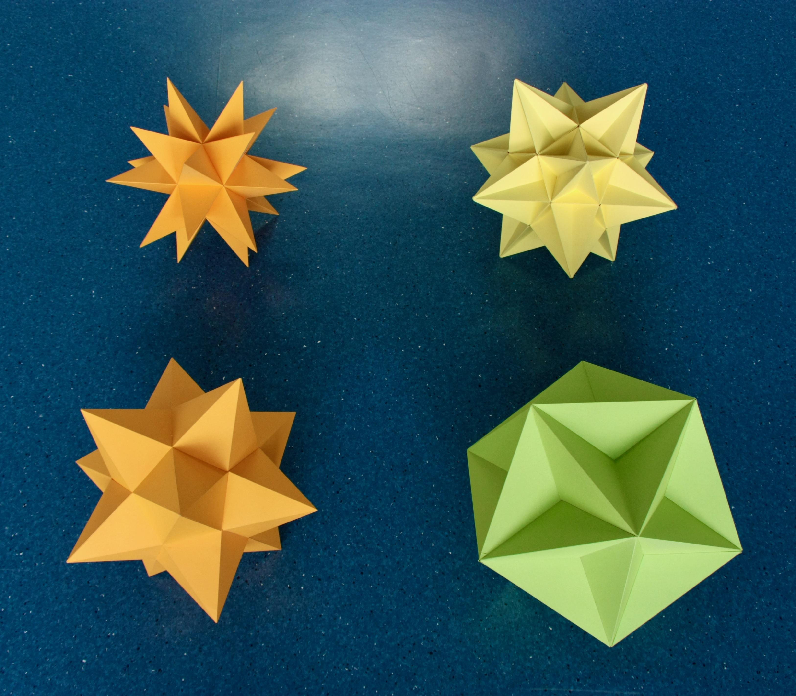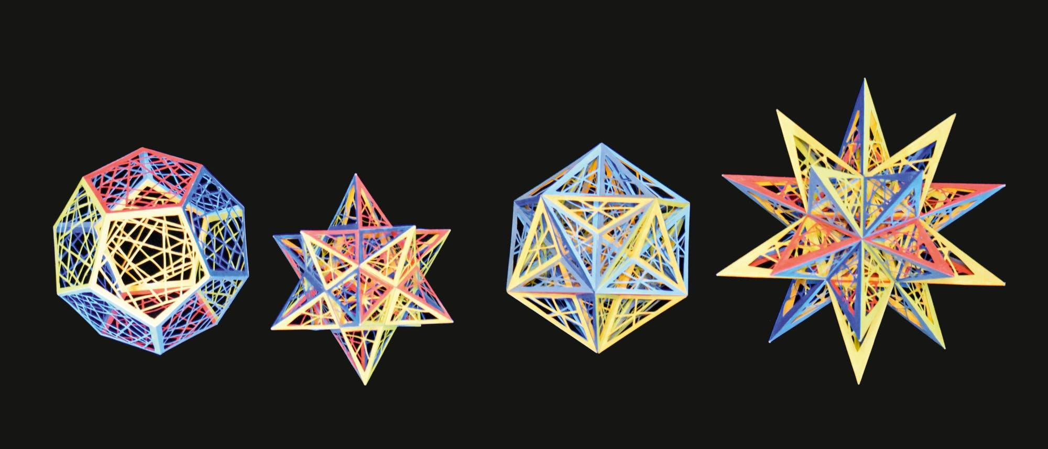

Geometric Structure
# Source: AI Source: Provided by: [Data Path: Persons Table -> ID Column: 1, Name_En Column: Motasem Essam] -> From: [ChatGPT] on [7/25/2026]
Kepler–Poinsot polyhedra are characterized by the following properties:
- They are regular, meaning their faces, edges, and vertices are arranged with complete geometric symmetry.
- They are non-convex, meaning their geometry contains intersecting or star-shaped structures.
- They are constructed using regular polygons or regular star polygons.
- Their faces may extend through other faces.
- Their vertex figures can be regular polygons or star polygons.
- They have icosahedral symmetry, including rotational and reflectional symmetries.
There are exactly four Kepler–Poinsot polyhedra in three-dimensional Euclidean geometry.

Types of Kepler–Poinsot Polyhedra
# Source: AI Source: Provided by: [Data Path: Persons Table -> ID Column: 1, Name_En Column: Motasem Essam] -> From: [ChatGPT] on [7/25/2026]
The four types are:
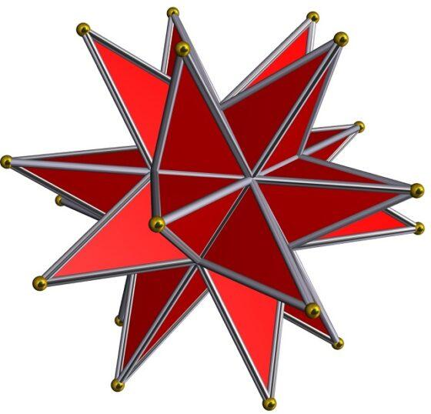

Small Stellated Dodecahedron
# Source: AI Source: Provided by: [Data Path: Persons Table -> ID Column: 1, Name_En Column: Motasem Essam] -> From: [ChatGPT] on [7/25/2026]
Schläfli symbol: $\{5/2,5\}$
A star polyhedron composed of 12 pentagrammic faces. Five pentagrams meet at each vertex.
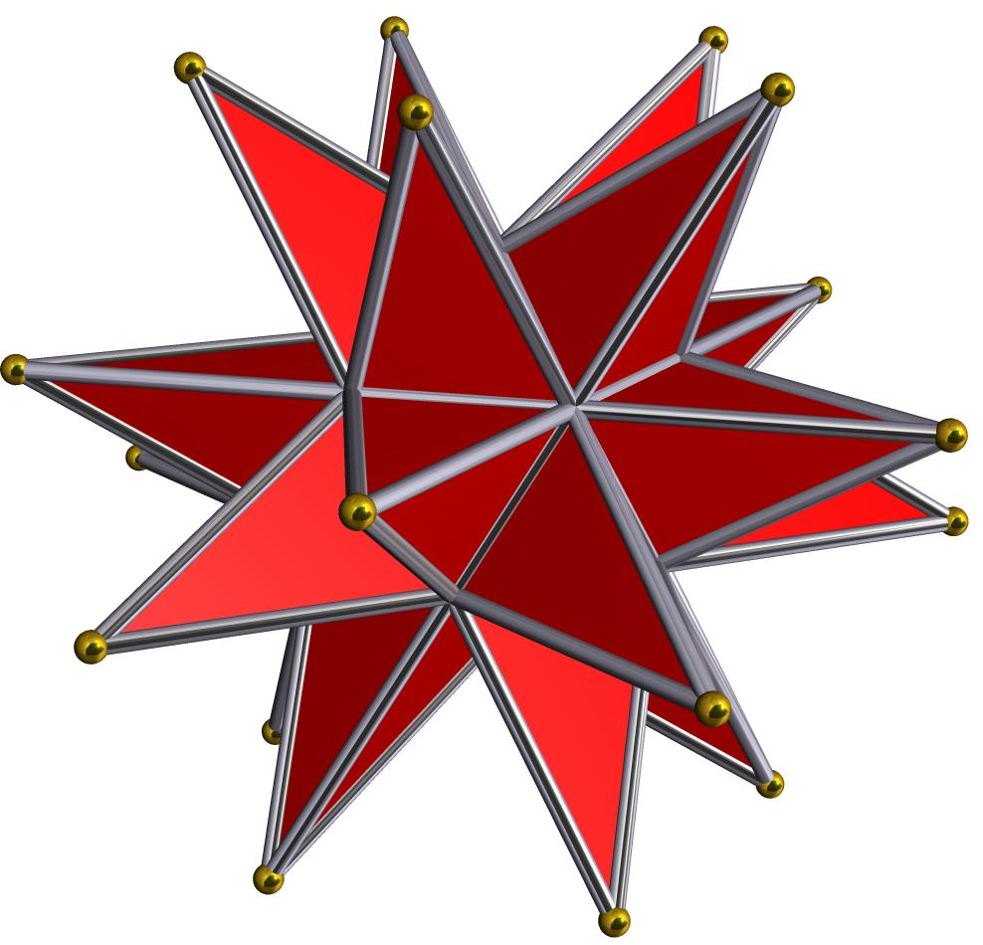

Great Stellated Dodecahedron
# Source: AI Source: Provided by: [Data Path: Persons Table -> ID Column: 1, Name_En Column: Motasem Essam] -> From: [ChatGPT] on [7/25/2026]
Schläfli symbol: $\{5/2,3\}$
A star polyhedron composed of 12 pentagrammic faces, with three faces meeting at each vertex.
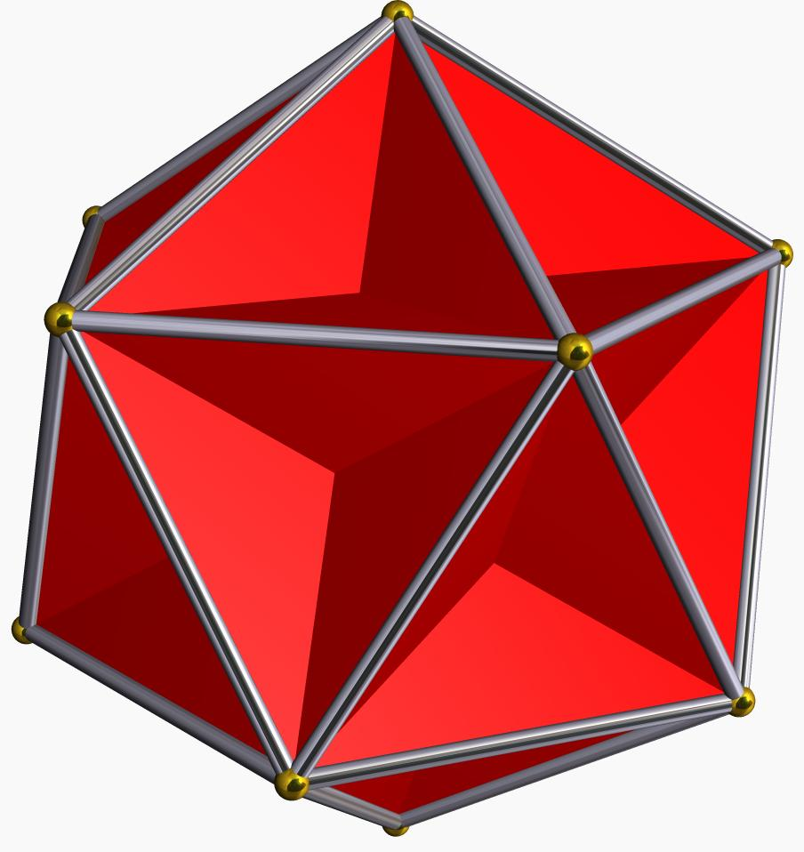

Great Dodecahedron
# Source: AI Source: Provided by: [Data Path: Persons Table -> ID Column: 1, Name_En Column: Motasem Essam] -> From: [ChatGPT] on [7/25/2026]
Schläfli symbol: $\{5,5/2\}$
A star polyhedron composed of 12 ordinary pentagonal faces, with a pentagrammic vertex figure.
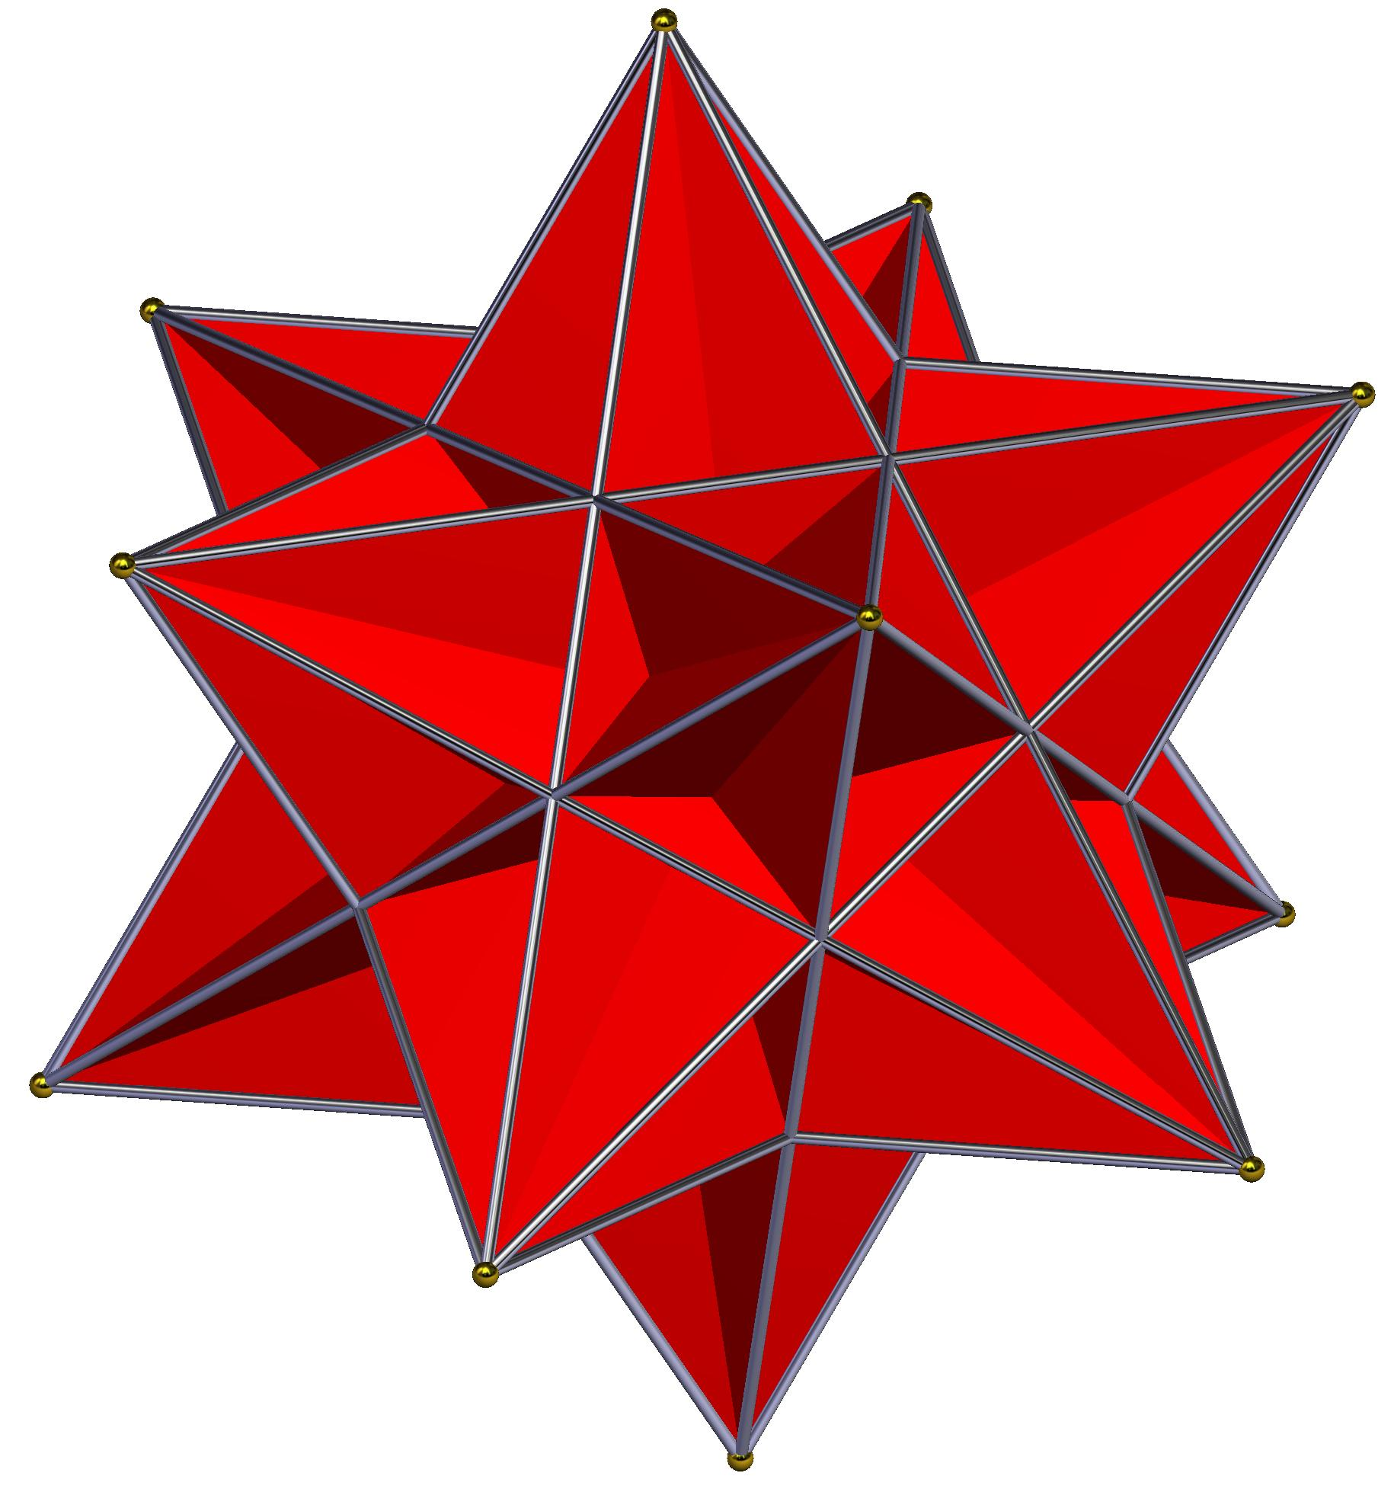

Great Icosahedron
# Source: AI Source: Provided by: [Data Path: Persons Table -> ID Column: 1, Name_En Column: Motasem Essam] -> From: [ChatGPT] on [7/25/2026]
Schläfli symbol: $\{3,5/2\}$
A star polyhedron composed of 20 ordinary triangular faces, with a pentagrammic vertex figure.

Mathematical Properties
# Source: AI Source: Provided by: [Data Path: Persons Table -> ID Column: 1, Name_En Column: Motasem Essam] -> From: [ChatGPT] on [7/25/2026]
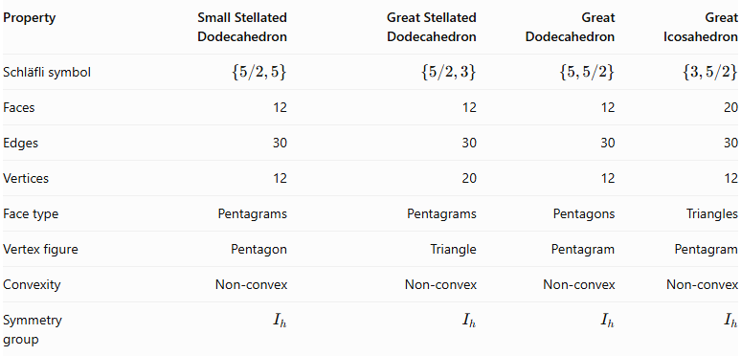
Property | Small Stellated Dodecahedron | Great Stellated Dodecahedron | Great Dodecahedron | Great Icosahedron
Schläfli symbol | $$\{5/2,5\}$$ | $$\{5/2,3\}$$ | $$\{5,5/2\}$$ | $$\{3,5/2\}$$
Faces | 12 | 12 | 12 | 20
Edges | 30 | 30 | 30 | 30
Vertices | 12 | 20 | 12 | 12
Face type | Pentagrams | Pentagrams | Pentagons | Triangles
Vertex figure | Pentagon | Triangle | Pentagram | Pentagram
Convexity | Non-convex | Non-convex | Non-convex | Non-convex
Symmetry group | $$I_{h}$$ | $$I_{h}$$ | $$I_{h}$$ | $$I_{h}$$
All four have full icosahedral symmetry, including rotations and reflections.

Face Composition and Schläfli Symbols
# Source: AI Source: Provided by: [Data Path: Persons Table -> ID Column: 1, Name_En Column: Motasem Essam] -> From: [ChatGPT] on [7/25/2026]
The Schläfli symbol $\{p,q\}$ describes a regular polyhedron:
- $p$ identifies the polygon or star polygon used for each face.
- $q$ identifies the polygonal arrangement of the vertex figure.
For star polygons, a fractional notation is used. For example:
$$\{\frac{5}{2}\}$$
represents a pentagram, formed by connecting every second vertex of a regular pentagon.
The four solids therefore have two different types of construction:
Pentagram-faced polyhedra
- Small Stellated Dodecahedron: $\{5/2,5\}$
- Great Stellated Dodecahedron: $\{5/2,3\}$
Ordinary-polygon-faced polyhedra with star vertex figures
- Great Dodecahedron: $\{5,5/2\}$
- Great Icosahedron: $\{3,5/2\}$

Geometric Construction
# Source: AI Source: Provided by: [Data Path: Persons Table -> ID Column: 1, Name_En Column: Motasem Essam] -> From: [ChatGPT] on [7/25/2026]
Kepler–Poinsot polyhedra are closely related to the regular dodecahedron and icosahedron.
They can be understood through two geometric operations:

Stellation
# Source: AI Source: Provided by: [Data Path: Persons Table -> ID Column: 1, Name_En Column: Motasem Essam] -> From: [ChatGPT] on [7/25/2026]
Stellation extends the faces or edges of a convex polyhedron until they intersect and form additional star-shaped regions.
This process produces the two stellated dodecahedra:
- Small Stellated Dodecahedron.
- Great Stellated Dodecahedron.

Regular Star-Polyhedron Construction
# Source: AI Source: Provided by: [Data Path: Persons Table -> ID Column: 1, Name_En Column: Motasem Essam] -> From: [ChatGPT] on [7/25/2026]
By allowing star-shaped vertex arrangements as well as ordinary polygonal faces, two additional regular polyhedra become possible:
- Great Dodecahedron.
- Great Icosahedron.
These four forms exhaust the regular star polyhedra in three-dimensional Euclidean geometry.

Duality Relationships
# Source: AI Source: Provided by: [Data Path: Persons Table -> ID Column: 1, Name_En Column: Motasem Essam] -> From: [ChatGPT] on [7/25/2026]
The four Kepler–Poinsot polyhedra form two dual pairs.
Pair 1: Small Stellated Dodecahedron and Great Dodecahedron
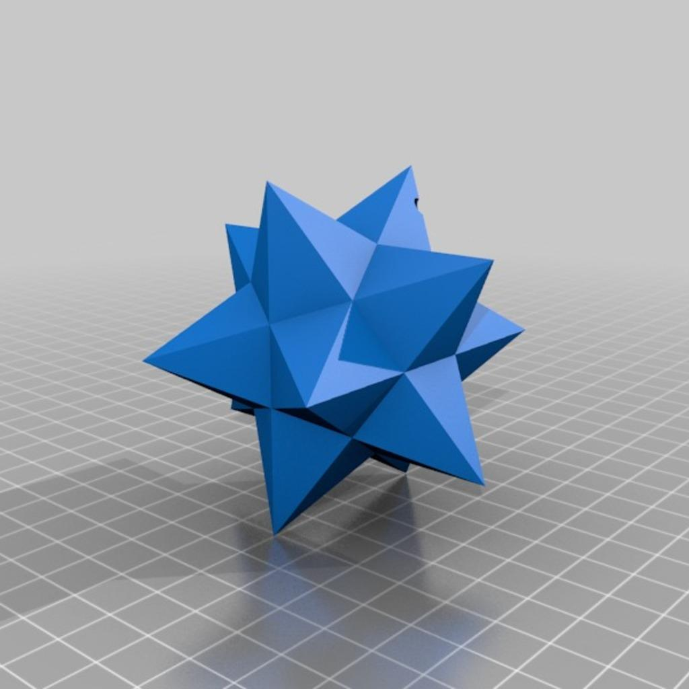
<icon name="arrow-left-right" color="secondary" size="xl"/>
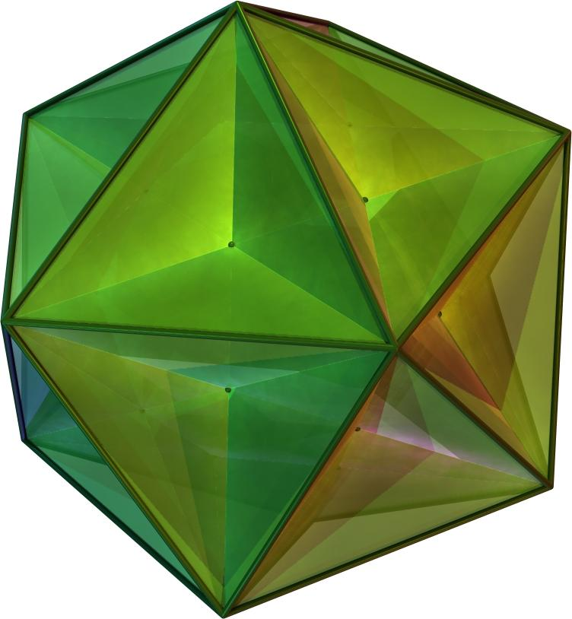
$$\{5/2,5\}longleftrightarrow\{5,5/2\}$$
Pair 2: Great Stellated Dodecahedron and Great Icosahedron
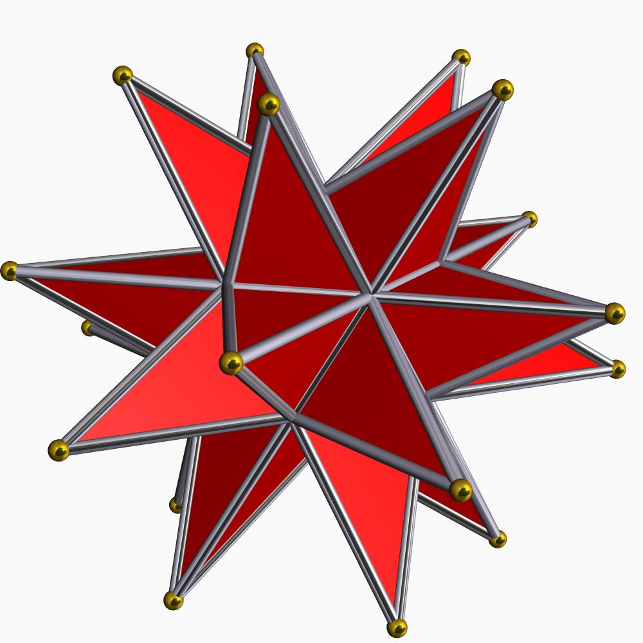
<icon name="arrow-left-right" color="secondary" size="xl"/>
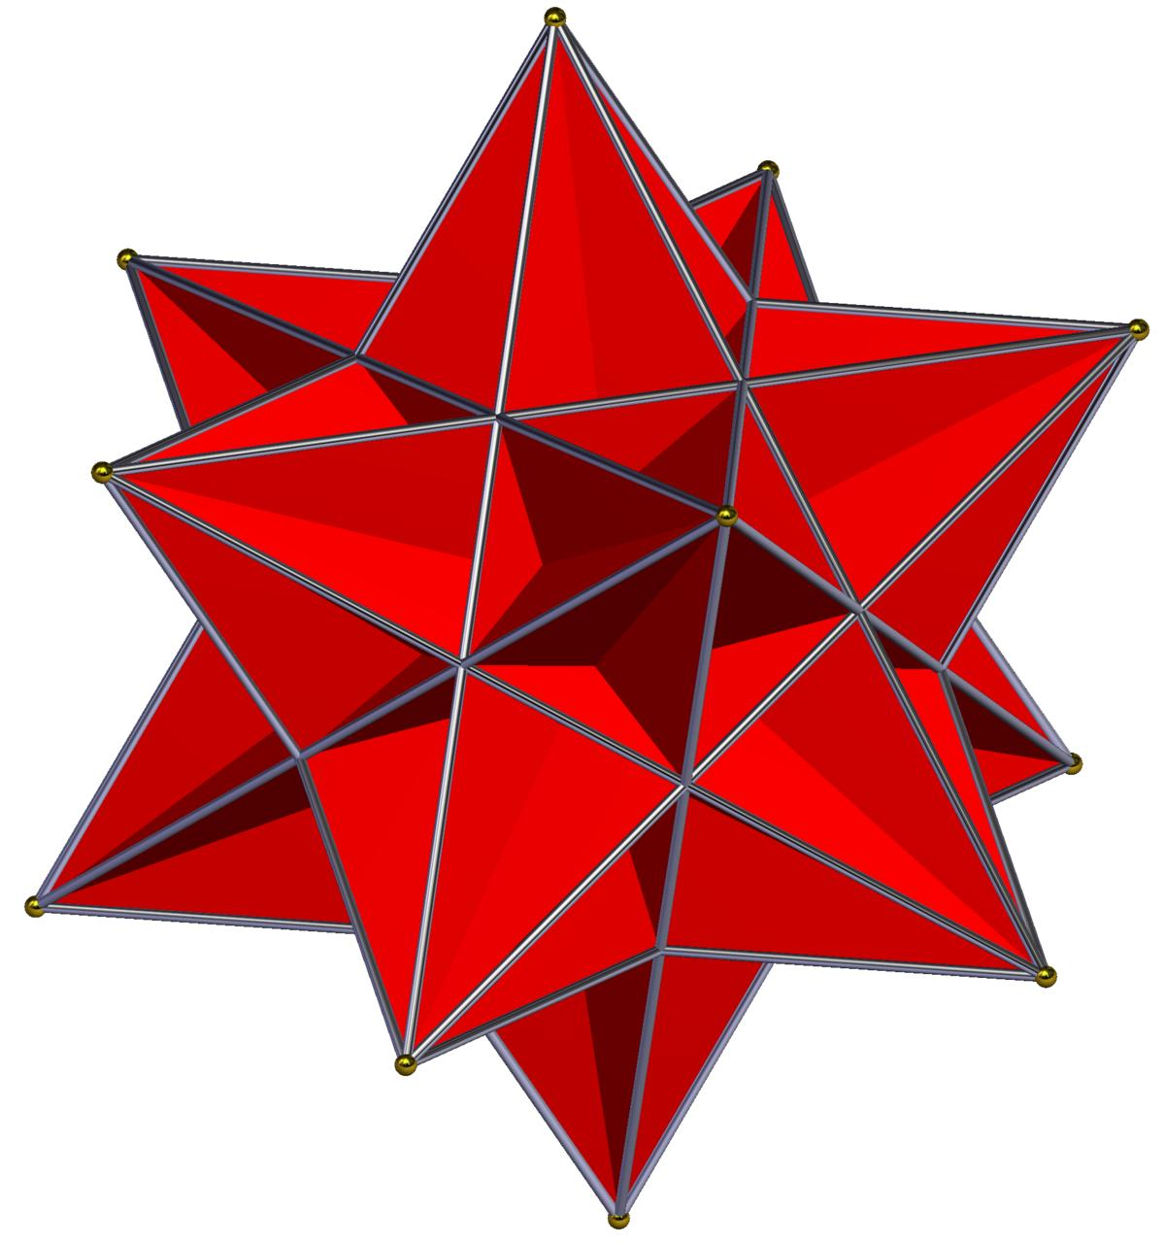
$$\{5/2,3\}longleftrightarrow\{3,5/2\}$$
In a dual relationship:
- Each face of the original polyhedron corresponds to a vertex of its dual.
- Each vertex of the original corresponds to a face of its dual.
- The number of edges remains unchanged.

Euler Characteristic
# Source: AI Source: Provided by: [Data Path: Persons Table -> ID Column: 1, Name_En Column: Motasem Essam] -> From: [ChatGPT] on [7/25/2026]
The Euler characteristic is calculated using:
$$χ=V-E+F$$
The values differ between the four polyhedra:
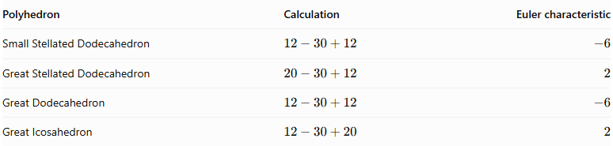
Polyhedron | Calculation | Euler characteristic
Small Stellated Dodecahedron | $$12-30+12$$ | $$-6$$
Great Stellated Dodecahedron | $$20-30+12$$ | $$2$$
Great Dodecahedron | $$12-30+12$$ | $$-6$$
Great Icosahedron | $$12-30+20$$ | $$2$$
The two polyhedra with Euler characteristic $-6$ do not satisfy the ordinary convex-polyhedron formula $V-E+F=2$ under this face-and-edge counting convention. This is a consequence of their star-polyhedron structure and its combinatorial interpretation.

Historical Background
# Source: AI Source: Provided by: [Data Path: Persons Table -> ID Column: 1, Name_En Column: Motasem Essam] -> From: [ChatGPT] on [7/25/2026]
The development of Kepler–Poinsot polyhedra involved several mathematicians:
- Johannes Kepler (1619): Described the small and great stellated dodecahedra in Harmonices Mundi.
- Louis Poinsot (1809): Rediscovered the great dodecahedron and great icosahedron.
- Augustin-Louis Cauchy (1813): Established that these four are the only regular star polyhedra in three dimensions.
- Arthur Cayley (1859): Helped establish the terminology used for the Kepler–Poinsot polyhedra.

Comparison with Platonic Solids
# Source: AI Source: Provided by: [Data Path: Persons Table -> ID Column: 1, Name_En Column: Motasem Essam] -> From: [ChatGPT] on [7/25/2026]
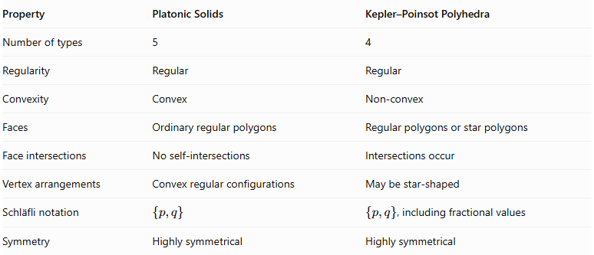
Property | Platonic Solids | Kepler–Poinsot Polyhedra
Number of types | 5 | 4
Regularity | Regular | Regular
Convexity | Convex | Non-convex
Faces | Ordinary regular polygons | Regular polygons or star polygons
Face intersections | No self-intersections | Intersections occur
Vertex arrangements | Convex regular configurations | May be star-shaped
Schläfli notation | $$\{p,q\}$$ | $\{p,q\}$, including fractional values
Symmetry | Highly symmetrical | Highly symmetrical
The Kepler–Poinsot polyhedra extend the classification of regular polyhedra by allowing self-intersections and star-polygon geometry.

Main Classification
# Source: AI Source: Provided by: [Data Path: Persons Table -> ID Column: 1, Name_En Column: Motasem Essam] -> From: [ChatGPT] on [7/25/2026]
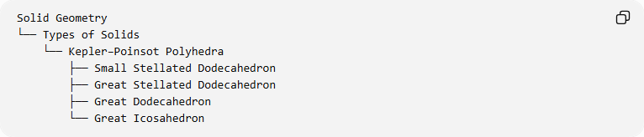
Solid Geometry
└── Types of Solids
└── Kepler–Poinsot Polyhedra
├── Small Stellated Dodecahedron
├── Great Stellated Dodecahedron
├── Great Dodecahedron
└── Great Icosahedron

Key Points
# Source: AI Source: Provided by: [Data Path: Persons Table -> ID Column: 1, Name_En Column: Motasem Essam] -> From: [ChatGPT] on [7/25/2026]
- Kepler–Poinsot polyhedra are the four regular non-convex polyhedra in three dimensions.
- They are also called regular star polyhedra.
- Two have pentagrammic faces.
- Two have ordinary polygonal faces but star-shaped vertex figures.
- All four have icosahedral symmetry $I_{h}$.
- They form two dual pairs.
- Their Schläfli symbols describe both ordinary and star-shaped configurations.
- They are closely related to stellations of the regular dodecahedron and icosahedron.
- They were studied by Kepler and Poinsot, with their classification established by Cauchy.

Conclusion
# Source: AI Source: Provided by: [Data Path: Persons Table -> ID Column: 1, Name_En Column: Motasem Essam] -> From: [ChatGPT] on [7/25/2026]
Kepler–Poinsot polyhedra represent the four regular star-shaped extensions of the Platonic solids. Their intersecting faces, pentagrammic structures, and highly symmetrical arrangements demonstrate how regular three-dimensional geometry can extend beyond convex polyhedra.
Sources for further study
- Wolfram MathWorld – Kepler–Poinsot Polyhedron
- Encyclopedia of Mathematics – Regular Polyhedra
- Maplesoft – The Kepler–Poinsot Solids

